Developed and designed by Owais Rashid Mir.

FloraPedia

Know your green counterparts

**FloraPedia** is developed and designed by:

* **Owais Rashid Mir**

Email: [mirowais414@gmail.com](mailto:mirowais414@gmail.com)

Phone : +91 91499 12066

**A BRIEF SUMMARY:**

This document is meant for describing all the features and procedures that were followed while developing **FloraPedia** . This document specially mentions the details of the project and how it was developed, the primary requirement, as well as various features and functionalities of the project and the procedures followed in achieving these objectives.

Over the years the manual plant management techniques have been carried across most of organizations and departments. These conventional techniques are hard to manage, not to mention hectic to traverse and not efficient in general.

To overcome the problems of this redundant way of representing plant data, we have developed an online, dynamic plant management system called **“FloraPedia”**. In this project, several technologies have been used that include HTML, CSS, Bootstrap, Javascript, Php and MySql.

The system communicates with database residing on a remote server. It manages the record of different plants without any manual paper-based work.

The system facilitates the end users with interactive design and automated processing of plant record management.

With the effective use, any organization or individual can use “FloraPedia” for viewing all the plants in our database and have a fully functional plant encyclopedia, just the distance of few keyboard clicks away, but I’ve specifically designed this website for the **Botany Department of Govt. Degree College Baramulla, Kashmir** under copyright with all rights reserved, who are solely responsible for managing the website and any unauthorized access may result in legal action again the perpetrator .

**CONTENTS:**

1. SRS [System Requirements Specifications]
2. Inspiration and The Scope of FloraPedia
3. Technologies used and their brief description
4. System Analysis
5. Requirement Analysis of FloraPedia
6. Software Development Model Used
7. Introduction To the Actual Project
8. Brief Summary of the Functionality
9. Architecture of FloraPedia
10. Diagrams:

* Service Diagram
* Data Flow Diagram [Level 0 DFD and Level 1 DFD]
* E-R Diagram

1. Database Structure
2. Understanding the functionality with the help of User Interface.
3. Files Structure and their Description
4. Folders
5. Bibliography

**SRS [System Requirements Specifications]:**

A software requirements specification (SRS) is a document that describes what the software will do and how it will be expected to perform. It also describes the functionality the product needs to fulfill for all stakeholders (business, users) needs.

A typical SRS includes:

• A purpose

• An overall description

• Specific requirements

All these topics will be covered detail in this report ranging from the introduction, to the technical details, the purpose, the description as well as the working. Technically, this entire document is an SRS.

**Inspiration and The Scope of FloraPedia:**

The idea of this project was given to us by the HOD of our department Prof. Arshad Ahmad Yatoo with a purpose in mind.

Before working on FloraPedia, we had plenty of ideas in mind that we discussed with Prof. Arshad, which he quickly pointed out that were pretty good but had not any application in the college. He emphasized that we should identify a real world problem in our surroundings and design a solution for that specific problem. He added we would have to put in the hours and the hard yards anyway, so why not spend time on something that will be actually worthwhile, saying we ultimately are going to leave the college at the end of the semester, so why not do something for the college while we were at it.

Then Sir Arshad suggested something that would take the shape of what we now call “**FloraPedia**.” He said that the Botany Department of GDC Baramulla needs a website for maintaining a plant database. Currently, they have to maintain a register/file containing the names of various plants along with the details as well as a sample leaf alongside to identify each plant. This approach, as he so rightly pointed out, had its fair share of lows and disadvantages. First of all, there aren’t many plants that you can put in a register and not all the students can access that register at a single time. Plus, the leaves that are pasted in the book decay and wear out after a period of time, rendering the manual database useless of sorts.

Then the work began, our journey of creating a fully functional plant encyclopedia for the Botany Department under the order and guidance of the HOD BCA Department Prof. Arshad Ahmad Yatoo.

**Technologies used and their brief description:**

**Front-end:**

* **HTML:**
* HTML stands for Hyper Text Markup Language
* HTML is the standard markup language for creating Web pages
* HTML describes the structure of a Web page
* HTML consists of a series of elements
* HTML elements tell the browser how to display the content
* HTML elements label pieces of content such as "this is a heading", "this is a paragraph", "this is a link", etc.
* **CSS:**

**C**ascading **S**tyle **S**heets, fondly referred to as **CSS**, is a simply designed language intended to simplify the process of making web pages presentable. CSS allows us to apply styles to web pages. More importantly, CSS enables us to do this independent of the HTML that makes up each web page.

* **CSS saves time:** We can write CSS once and reuse same sheet in multiple HTML pages.
* **Easy Maintenance:** To make a global change simply change the style, and all elements in all the web pages will be updated automatically.
* **Search Engines:** CSS is considered as clean coding technique, which means search engines won’t have to struggle to “read” its content.
* **Bootstrap:**

“The most popular HTML, CSS, and JS framework for developing responsive, mobile first projects on the web.”

**In layman’s terms:** Bootstrap is a giant collection of handy, reusable bits of code written in HTML, CSS, and JavaScript. It’s also a front-end development framework that enables developers & designers to quickly build fully responsive websites.

**Bootstrap saves you from writing lots of CSS code**, giving you more time to spend on designing webpages.

* **Javascript:**

JavaScript is a dynamic computer programming language. It is lightweight and most commonly used as a part of web pages, whose implementations allow client-side script to interact with the user and make dynamic pages. It is an interpreted programming language with object-oriented capabilities.

**Back-end:**

* **PHP**:

PHP stands for **Hypertext Pre-Processor**. PHP is a scripting language used to develop static and dynamic WebPages and web applications. Here are a few important things you must know about PHP:

* PHP is an Interpreted language; hence it doesn't need a compiler.
* To run and execute PHP code, we need a Web server on which PHP must be installed.
* PHP is a server side scripting language, which means that PHP is executed on the server and the result is sent to the browser in plain HTML.
* PHP is open source and free.

**Database:**

* **MySql:**
* MySQL is an open-source, fast reliable, and flexible relational database management system, typically used with PHP.
* MySQL is a database system used for developing web-based software applications.
* MySQL is used for both small and large applications.
* MySQL is a relational database management system (RDBMS).
* MySQL is fast, reliable, and flexible and easy to use.
* MySQL supports standard SQL (Structured Query Language).
* MySQL is free to download and use.
* MySQL is presently developed, distributed, and supported by Oracle Corporation.
* MySQL is Written in C, C++.

# SYSTEM ANALYSIS:

## Existing System [A brief description]:-

System Analysis is a detailed study of the various operations performed by a system and their relationships within and outside of the system. Here the key question is- what all problems exist in the present system? What must be done to solve the problem? Analysis begins when a user or manager begins a study of the program using existing system.

 During analysis, data is collected on the various files, decision points and transactions handled by the present system. The commonly used tools in the system are Data Flow Diagram, interviews, etc. Training, experience and common sense are required for collection of relevant information needed to develop the system. The success of the system depends largely on how clearly the problem is defined, thoroughly investigated and properly carried out through the choice of solution. A good analysis model should provide not only the mechanisms of problem understanding but also the framework of the solution. Thus, it should be studied thoroughly by collecting data about the system. Then the proposed system should be analyzed thoroughly in accordance with the needs.

System analysis can be categorized into four parts.

* System planning and initial investigation
* Information Gathering
* Applying analysis tools for structured analysis
* Feasibility study
* Cost/ Benefit analysis.

In the current system, we need to keep a number of records related to the plants and want to enter the details of the plants into the database. In this system, only the admin updates or deletes the plant related information and the users can search, view, explore, provide feedback etc.

## Proposed System:

In our proposed system, we have the provision for adding the details of the plants by the admin so the users can simply visit our website and get all the information in just a few clicks. Another advantage of the system is that it is very easy to edit the details of the plants and delete a plant when it is found unnecessary. The detailed description of the plants is added as well in the database so that the users can have all the information they need in one place.

Our website has several advantages

* User friendly interface
* Fast access to database
* More Storage Capacity
* Search facility
* Look and Feel Environment

## Feasibility Analysis -

It is wise to think about the feasibility of any problem we undertake. Feasibility is the study of impact, which happens in the organization by the development of a system. The impact can be either positive or negative. When the positives nominate the negatives, then the system is considered feasible. Here the feasibility study can be performed in two ways such as Technical Feasibility and Economical Feasibility.

### Technical Feasibility:

 We can strongly says that it is technically feasible, since there will not be much difficulty in getting required resources for the development and maintaining the system as well. All the resources needed for the development of the software as well as the maintenance of the same is available in the organization here we are utilizing the resources which are available already.

### Economical Feasibility:

Development of this application is highly economically feasible. The organization needed not spend much money for the development of the system already available. The only thing is to be done is making an environment for the development with an effective supervision. If we are doing so, we can attain the maximum usability of the corresponding resources .Even after the development, the organization will not be in condition to invest more in the organization .Therefore, the system is economically feasible.

**REQUIREMENT ANALYSIS OF FLORAPEDIA:**

As mentioned multiple times, this project is a fully functional encyclopedia of plants.

For developing this website, various requirements had to be fulfilled that lead to a fully robust and dynamic end product. The most important thing required to build this was a pretty extensive knowledge of the technologies used in the projects. Almost the entire project was developed using HTML, JAVASCRIPT, CSS, BOOTSTRAP, PHP AND MYSQL. It would have been an impossible feat if we didn’t have any working knowledge of how to code using the above languages and technologies.

Moreover, we had to contact various experts in the field of Botany and had to refer to plenty of books in order to come to terms with what and how the fields of information were to be put, corresponding to a particular plant, and what details were really needed to be displayed in our website.

Then, we had to make sure that we had all the services needed to support the development technologies i.e. MySql and Apache services, which we easily incorporated using the XAMPP server. Then, we also needed to incorporate plenty of plugins and libraries at various points in our project, such as “Font Awesome icons”- to make our interface more catchy and user friendly as well as “TinyMce Editor”- that contains a plugin which provides rich text editing functionalities for HTML input elements.

**Software Development Model Used:**

The development team of **FloraPedia** has strictly followed the **Agile Development Model**. At each step, the team remained true to the constraints of the model and respected its flexibility as well as its limitation that lead to the development of the final product in a systematic manner, without any major hiccups and the need to alter the pattern of designing and coding.

**Brief description of the Agile Model:**

Agile SDLC model is a combination of iterative and incremental process models with focus on process adaptability and customer satisfaction by rapid delivery of working software product. Agile Methods break the product into small incremental builds. These builds are provided in iterations. Each iteration typically lasts from about one to three weeks. Every iteration involves cross functional teams working simultaneously on various areas like :

* Planning
* Requirements Analysis
* Design
* Coding
* Unit Testing and
* Acceptance Testing.

## What is Agile?

Agile model believes that every project needs to be handled differently and the existing methods need to be tailored to best suit the project requirements. In Agile, the tasks are divided to time boxes (small time frames) to deliver specific features for a release.

Iterative approach is taken and working software build is delivered after each iteration. Each build is incremental in terms of features; the final build holds all the features required by the customer.

Here is a graphical illustration of the Agile Model –

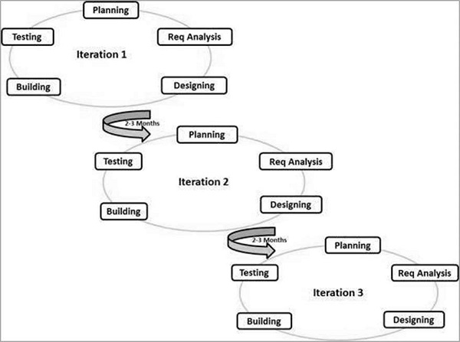

The Agile thought process had started early in the software development and started becoming popular with time due to its flexibility and adaptability.

The most popular Agile methods include Rational Unified Process (1994), Scrum (1995), Crystal Clear, Extreme Programming (1996), Adaptive Software Development, Feature Driven Development, and Dynamic Systems Development Method (DSDM) (1995). These are now collectively referred to as **Agile Methodologies**, after the Agile Manifesto was published in 2001.

Following are the Agile Manifesto principles –

* **Individuals and interactions** − In Agile development, self-organization and motivation are important, as are interactions like co-location and pair programming.
* **Working software** − Demo working software is considered the best means of communication with the customers to understand their requirements, instead of just depending on documentation.
* **Customer collaboration** − As the requirements cannot be gathered completely in the beginning of the project due to various factors, continuous customer interaction is very important to get proper product requirements.
* **Responding to change** − Agile Development is focused on quick responses to change and continuous development.

|  |
| --- |
|  |

**Introduction:**

What is **FloraPedia**?

* FloraPedia is an fully functional online encyclopedia of digitized plant specimens.
* FloraPedia is a working list of known plant species. Our website is equipped with a powerful search functionality with which users can find any plant in our database by writing its Common name, Botanical name, Genus, Specie or the Family.
* Our site provides accurate, standardized and verified information about plants along with their pictures and detailed description.
* Users can also view our huge repository of plants and much more.

Brief Summary of the functionality:

**User-End Functionality:**

* Search plants
* Browse and view plants
* Discover plants
* View plant gallery
* Login as administrator
* Provide feedbacks
* Report problems and much more.

**Admin-End Functionality:**

* Dashboard navigation
* Search plants
* Browse and view plants
* Discover plants
* Add plants
* Edit plants
* Delete plants
* Add admins
* View/delete feedbacks
* View/delete reports and much more

*[The functionality will be discussed in detail later on.]*

**Architecture of FloraPedia:**

**FloraPedia**

**ADMIN-END**

**USER-END**

1. User-End: A user has limited access to the site. Users can browse data of our database, discover information, search data, provide feedbacks, report problems and much more.

Service Diagram of the User-End:



USER

1. Admin-End: An administrator has access to the full functionality of the site. Not only can an admin can view data but he can also add, edit and delete data in the database. Moreover, the admin has the authorization to add another admin, view feedbacks/reports and much more.

Service Diagram of the Admin-End:

**The Data Flow Diagram:**

 A Data Flow Diagram (DFD) is a traditional way to visualize the information flows within a system. It shows how information enters and leaves the system, what changes the information and where information is stored.

**­­­**

**Registering a plant**

Administrator

A particular Plant

Adds to the database

Added to the database by

Level 0 DFD

Administrator

Database

Request to add, edit, view, delete plant and view feedback

Grants login by consulting database

Consults for granting user requests

Request login

Level 1 DFD

Checks admin validity

Requests to view and provide feedback

User

**ER-DIAGRAM:**

**ER Diagram- Introduction:**

An Entity–Relationship model (ER model) describes inter-related things of interest in a specific domain of knowledge. An ER model is composed of entity types (which classify the things of interest) and specifies relationships that can exist between instances of those entity types. In software engineering, an ER model is commonly formed to represent things that a business needs to remember in order to perform business processes. Consequently, the ER model becomes an abstract data model that defines a data or information structure that can be implemented in a database, typically a relational database.

Entity–relationship modeling was developed for database design by Peter Chen and published in a 1976 paper. However, variants of the idea existed previously, some ER modelers show super and subtype entities connected by generalization-specialization relationships, and an ER model can be used also in the specification of domain-specific ontology.

An ER model is typically implemented as a database. In a simple relational database implementation, each row of a table represents one instance of an entity type, and each field in a table represents an attribute type. In a relational database, a relationship between entities is implemented by storing the primary key of one entity as a pointer or "foreign key" in the table of another entity There is a tradition for ER/data models to be built at two or three levels of abstraction. Note that the conceptual-logical-physical hierarchy below is used in other kinds of specification, and is different from the three schema approach to software engineering.

**Conceptual data model:**

This is the highest level ER model that contains the least granular detail but establishes the overall scope of what is to be included within the model set. The conceptual ER model normally defines master reference data entities that are commonly used by the organization. Developing an enterprise-wide conceptual ER model is useful to support documenting the data architecture for an organization.

**Logical data model:**

A logical ER model does not require a conceptual ER model, especially if the scope of the logical ER model includes only the development of a distinct information system. The logical ER model contains more detail than the conceptual ER model. In addition to master data entities, operational and transactional data entities are now defined. The details of each data entity are developed and the relationships between these data entities are established. The logical ER model is however developed independent of technology into which it can be implemented.

**Physical data model:**

One or more physical ER models may be developed from each logical ER model. The physical ER model is normally developed to be instantiated as a database. Therefore, each physical ER model must contain enough detail to produce a database and each physical ER model is technology dependent since each database management system is somewhat different.

**ER Diagram- FloraPedia:**

Manages

Plant database

Admin

Viewed by

**Database Structure:**

Name of the Database: **botany_db**

botany_db

**feedback_and_report**

**login**

**plant_detail**

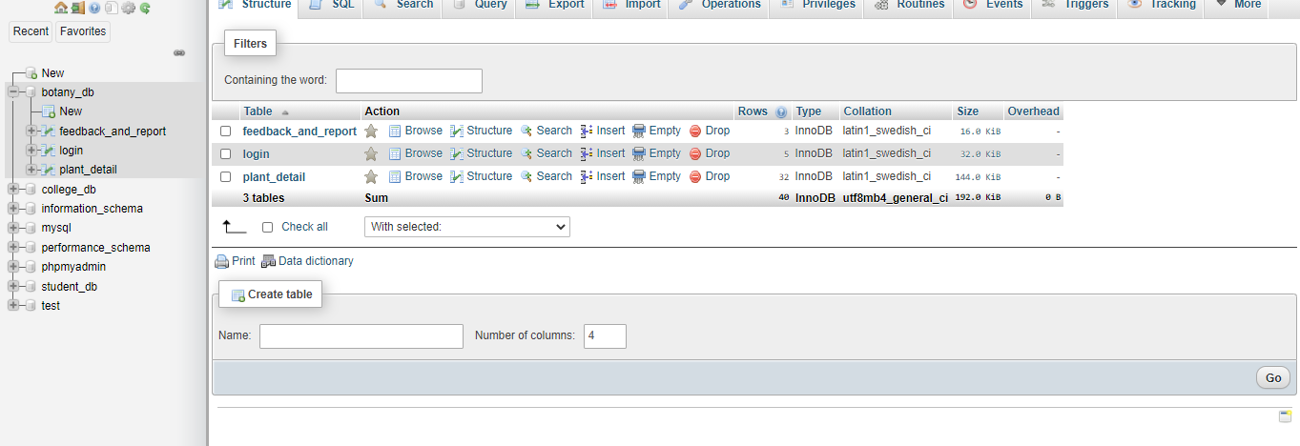

The database contains three tables discussed below.

**Description of Database tables:**

**Table1-** **plant_detail:**

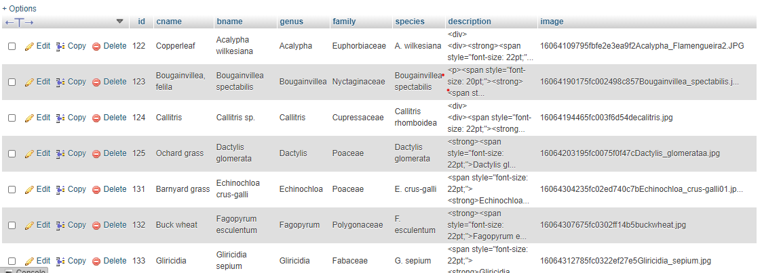

This is the main table which store all the details related to a particular plant. It contains many field as discussed below:

* **id:** id of the plant. This acts as the primary key.
* **cname**: common name of the plant.
* **bname**: botanical name of the plant.
* **genus**: genus of the plant.
* **Family** : family of the plant.
* **species**: specie of the plant.
* **description**: contains detailed description of the plant.
* **image**: stores the path of the image corresponding to each particular plant.

**Table2- login:**

This table store the login credentials of all the registered admins of the website . The columns include:

* **Id**: The id of every admin. This acts as the primary key.
* **Emai**l: email id of every admin which acts as the username.
* **Password**: the password corresponding to each email. The passwords are stored in an encrypted format in the database for added security.

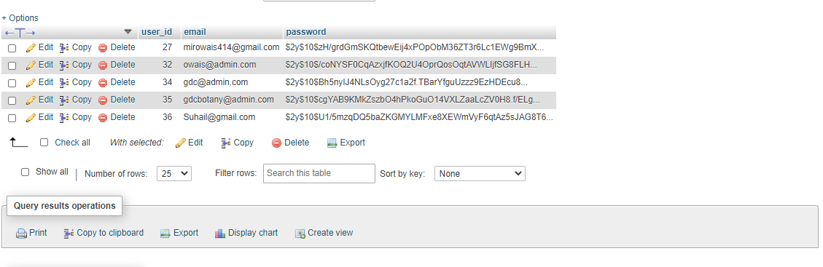

**Table3-** **feedback_and_report**:

This table contains all the feedbacks and reports sent by the users of the site. The table contains 6 columns:

* **Id**: This is simply given according to the order a feedback was recieved. This acts as the primary key.
* **Emai**l: email id of every user who provides a feedback or a report.
* **feedbackOrReport:** simply specifies whether the given user information is a “feedback” or a “report.”
* **Subject:** it is the subject or the heading of the user feedback.
* **description:** it is the detailed description of the user feedback.

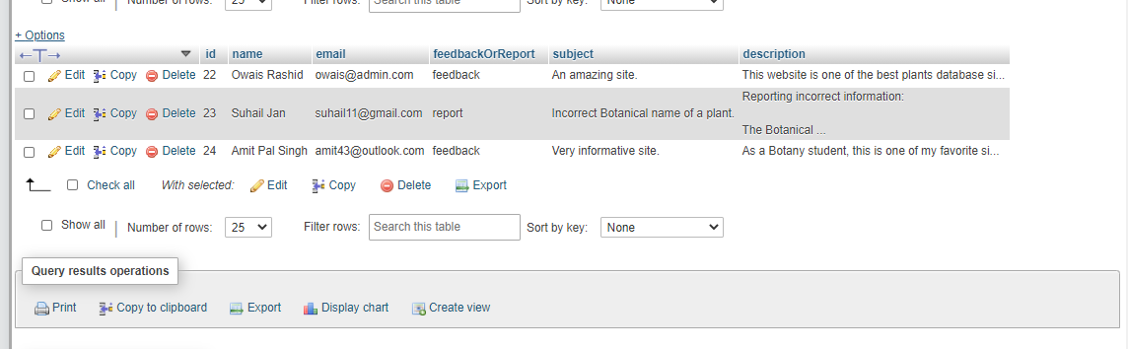

**Understanding the functionality with the help of the Interface:**

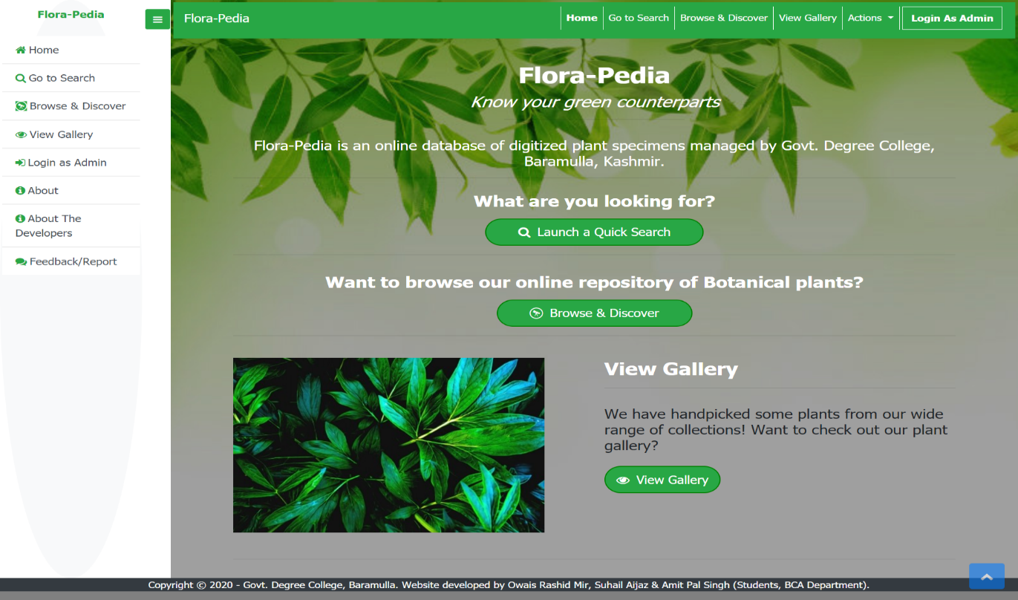

This is the homepage of the website which contains a collapsible Navbar and a Sidebar, both equipped with plenty of shortcuts. Users can quickly navigate to any page by clicking on the shortcut links in the Navbar, Sidebar or the main homepage.

This webpage as well as all the other ones will automatically adapt to the dimensions of different digital devices, i.e. all the webpages are mobile responsive.

* The main attraction of the homepage is the search functionality with which the user can search data by clicking on “**Launch a quick Search”** button.
* The user can also click on the “**Browse and Discover**” option by virtue of which he can explore all the plants in our repository in its entirety. This option may come in handy for note making purposes.
* The site also has the “**View Gallery”** page**,** which contains some handpicked plantsby the developers that are sure to leave the users mesmerized.
* User can also navigate to the “**feedback and report**” section directly from the homepage to give a feedback or report any sort of problems, bugs and incorrect information.
* The homepage also contains a “**Login as admin**” option in the nav-bar as well as the sidebar.
* Users can get information about the site and its developers by clicking on **About** and **About The Developers** webpages.

**Find anything with our search functionality:**

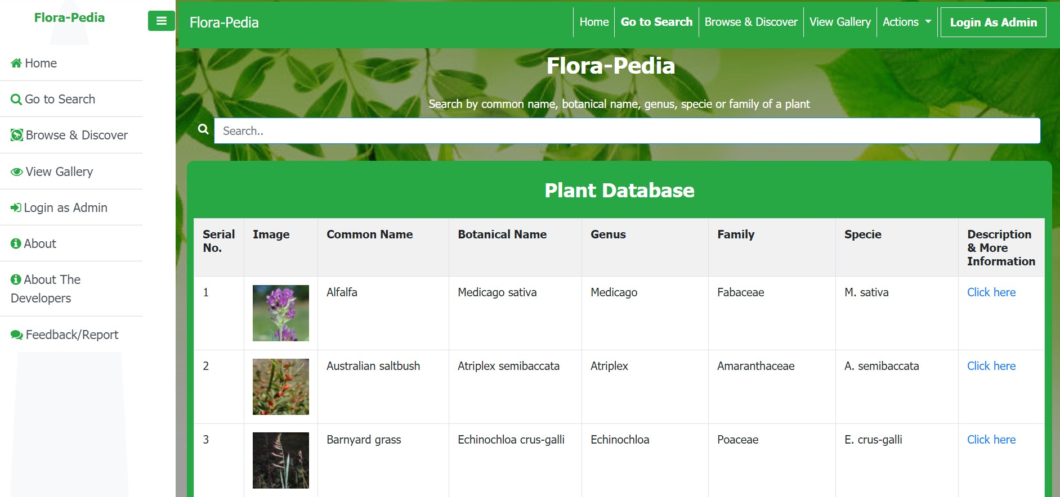

FloraPedia has a powerful search functionality with which a user can search a plant in our database by its *Common name*, *Botanical name, Genus, Specie or the Family*. It is a live search, i.e. it will start searching and displaying the results as soon as the user starts typing the search keywords. Built with *Javascript,* it is a reliable and an accurate search which can match the strings and sub-strings among all the mentioned columns simultaneously.

It has been programmed in such a way that if multiple data entries match the entered search string, all of them will be listed.

Eg: If the user wants to list all the plants belonging to a particular species, he can easily do that by simply typing the specie name in the search box.

Browse our online repository of Botanical plants with **Browse & Discover** section:

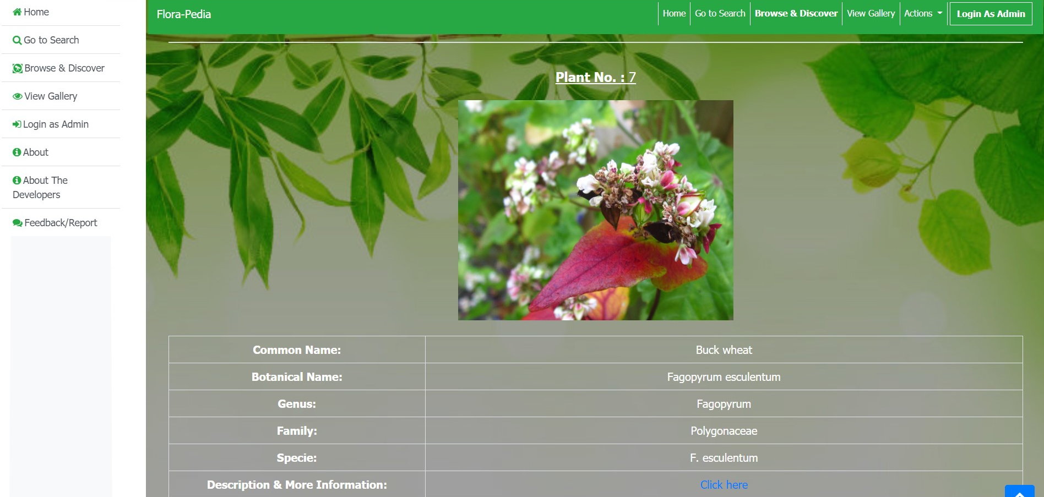

As discussed earlier, the “**Browse and Discover**” page allows the user to explore all the plants in our repository in its entirety. This option may come in handy for note making purposes.

“**Display description**” page: which provides the in-depth detail about a plant.

Users can view all the plant info, detailed description and the image in this page:

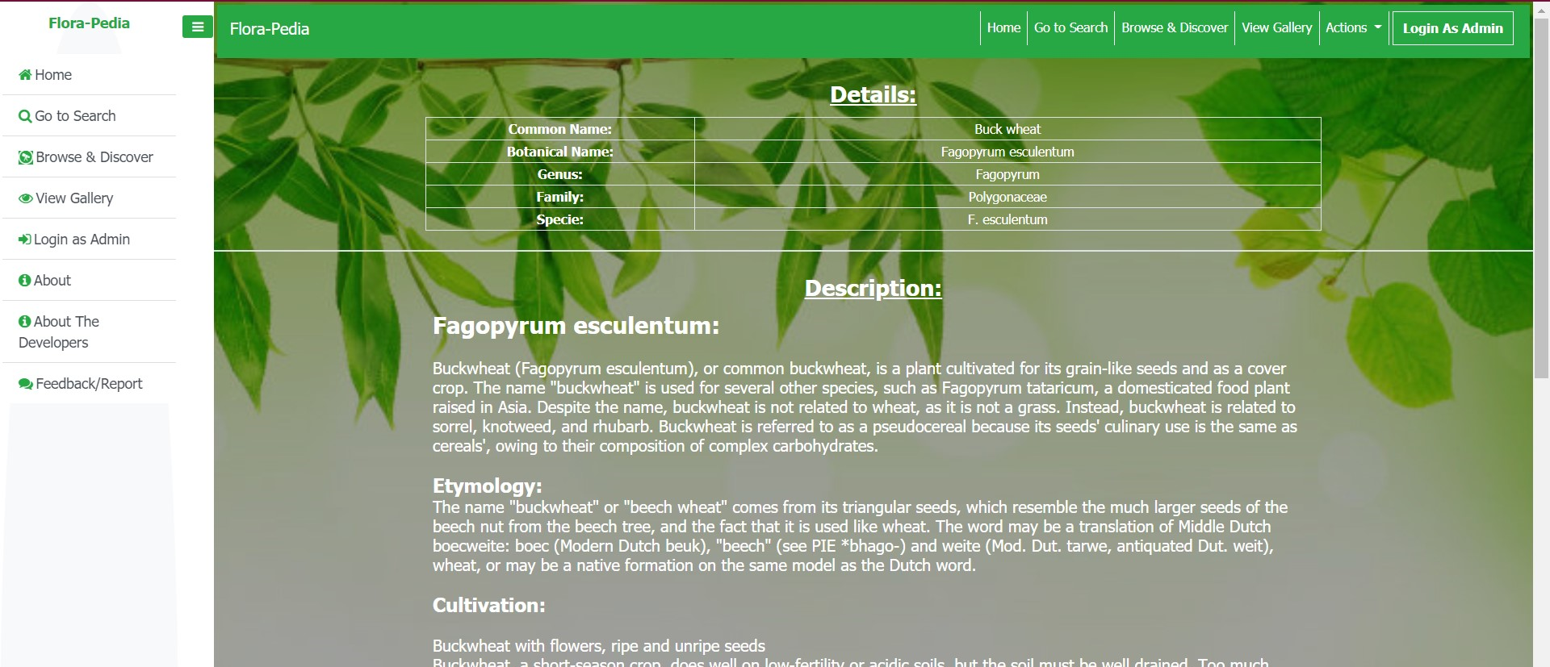

This page, which can be navigated from various points of the website, most commonly through a hyperlink attached to each plant in the last column of the table present on the “**Search page**” and well as the “**Browse and discover**” section provides a detailed description of the particular plant against which the link is clicked.

Feedback/Report:

Users can give feedbacks, report bugs, errors and incorrect information.

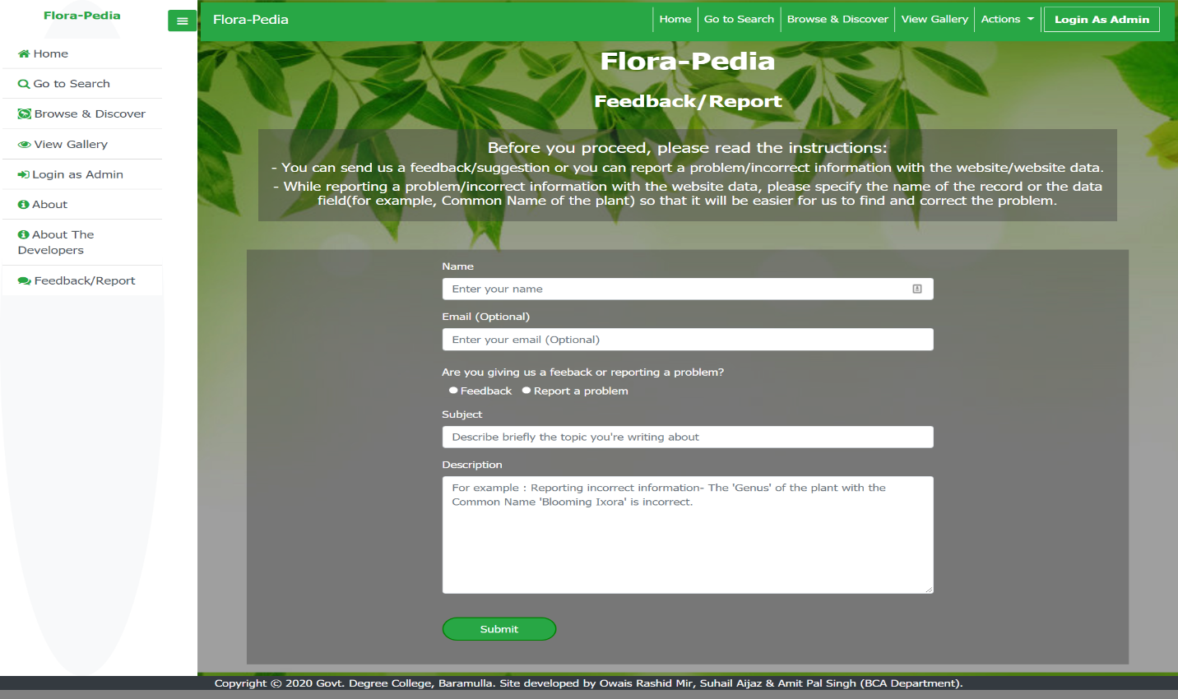

An admin can view feedbacks/reports and take appropriate actions.

This Feedback system is solely created for improving the user experience.

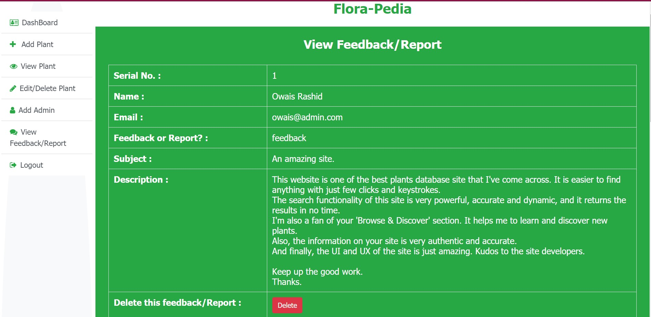

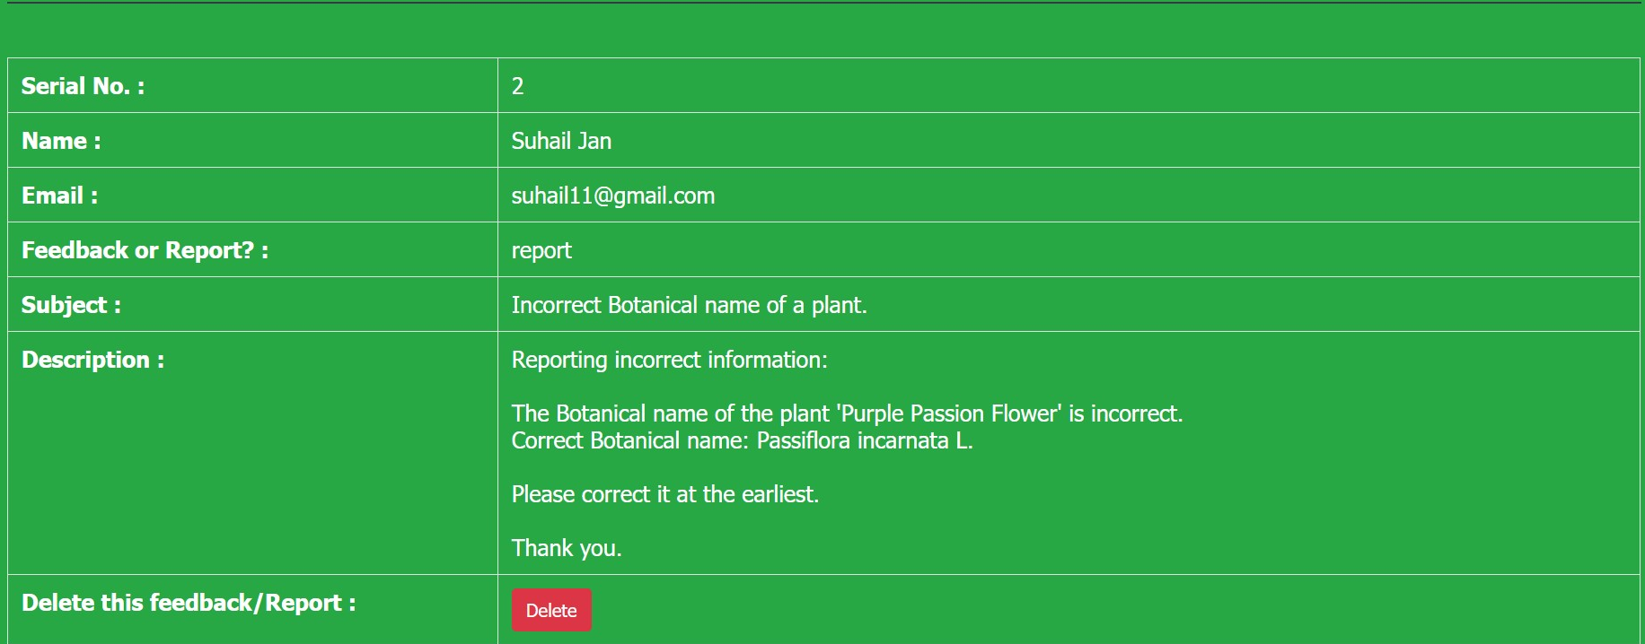

Admin Panel Dashboard:

An administrator has access to the full functionality of the site. An admin can view, add, edit and delete data. Moreover, the admin can add other administrators as well.

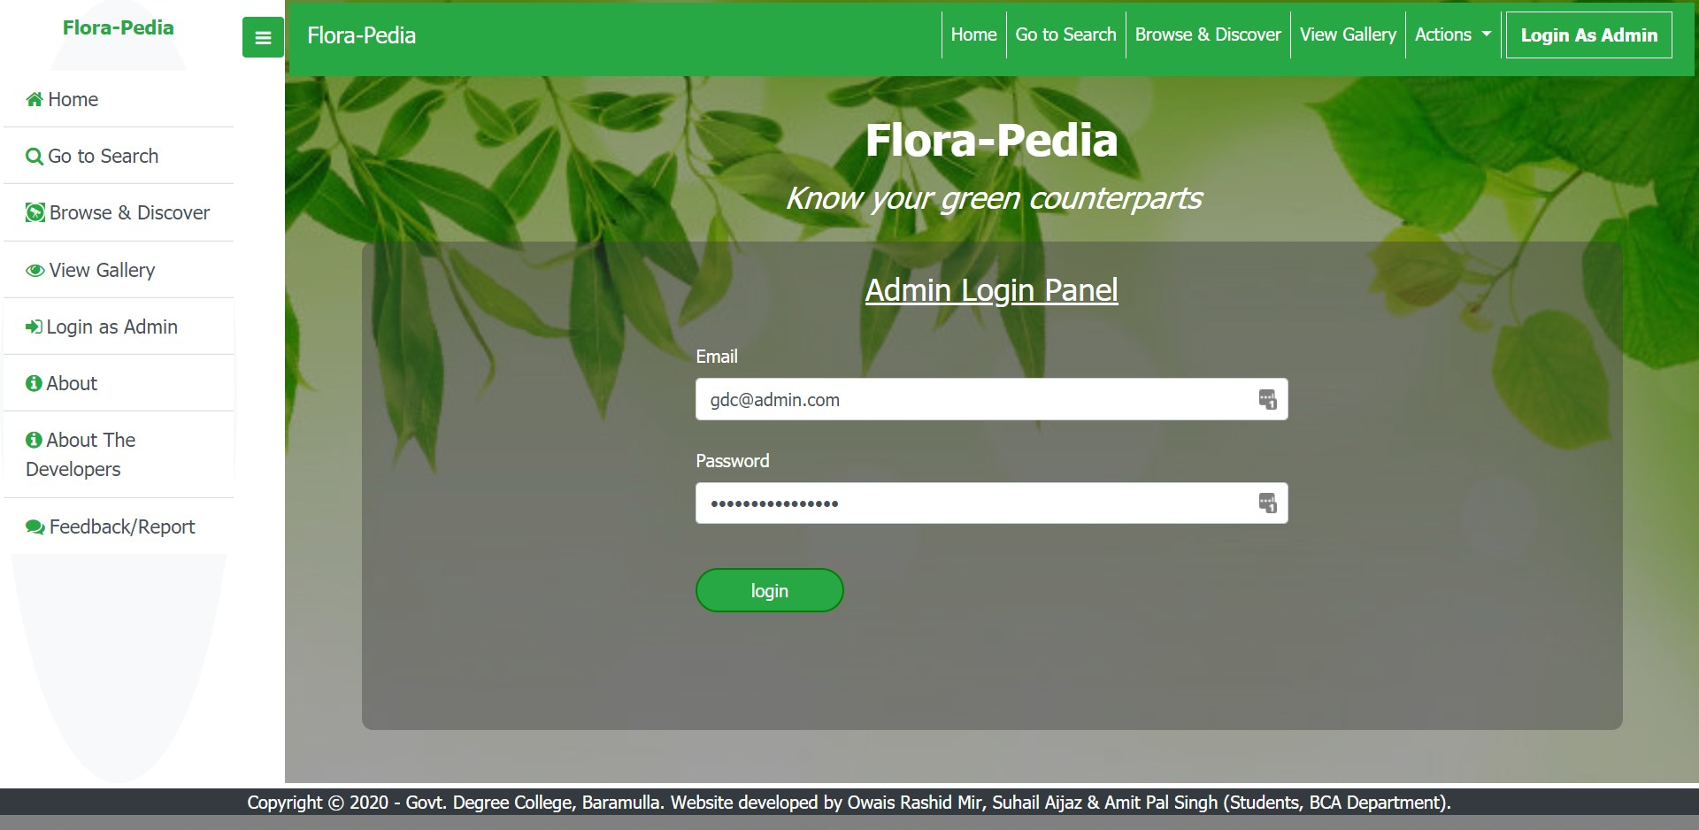

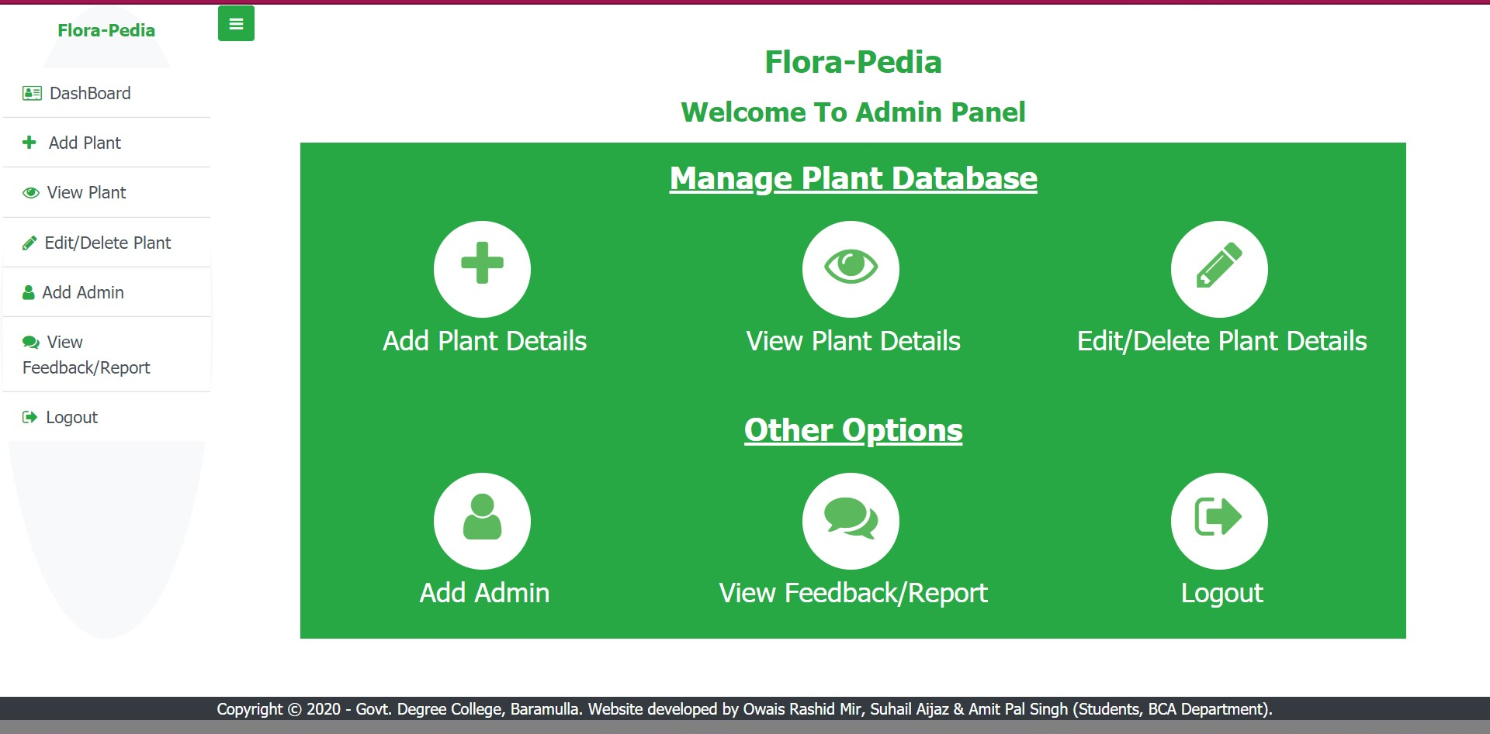

Administrators have the privilege to add data:

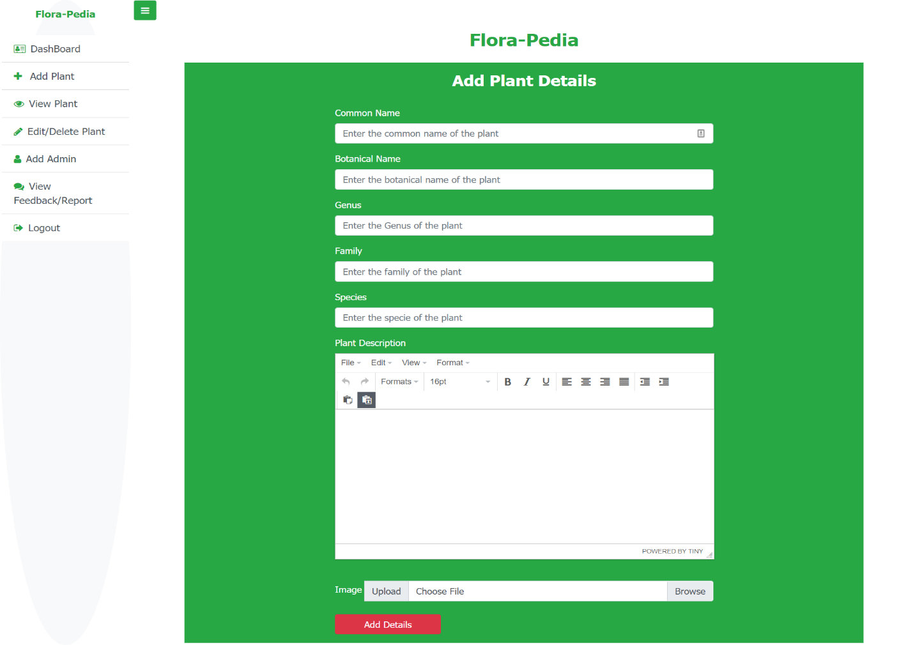

Similarly, admins can Edit/Delete data:

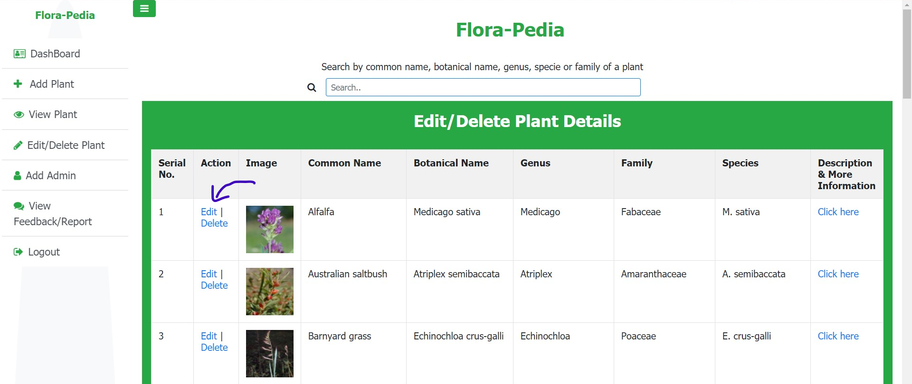

Deleting Information:

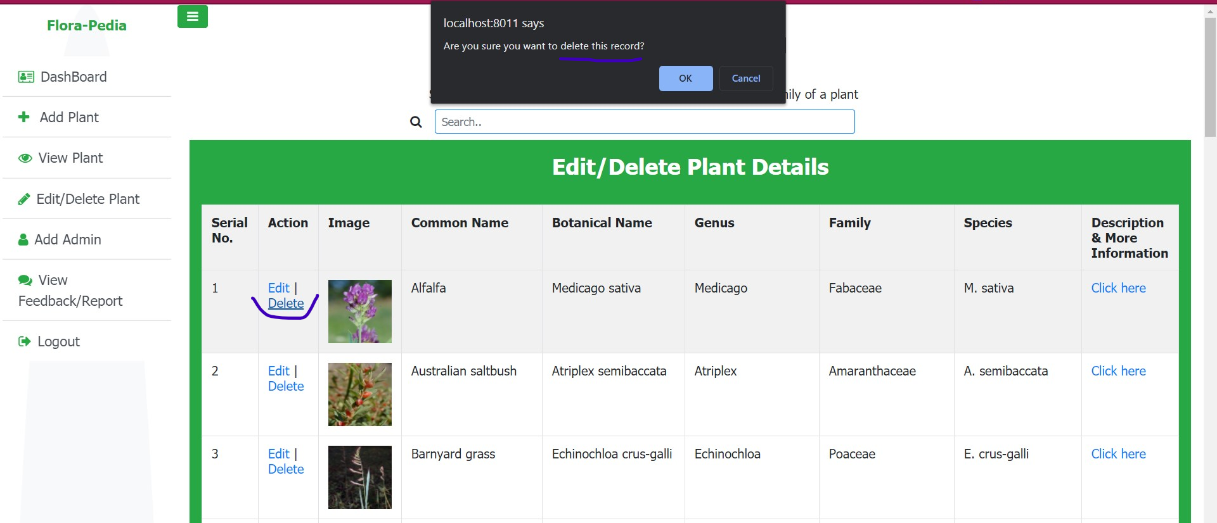

Adding other admins:

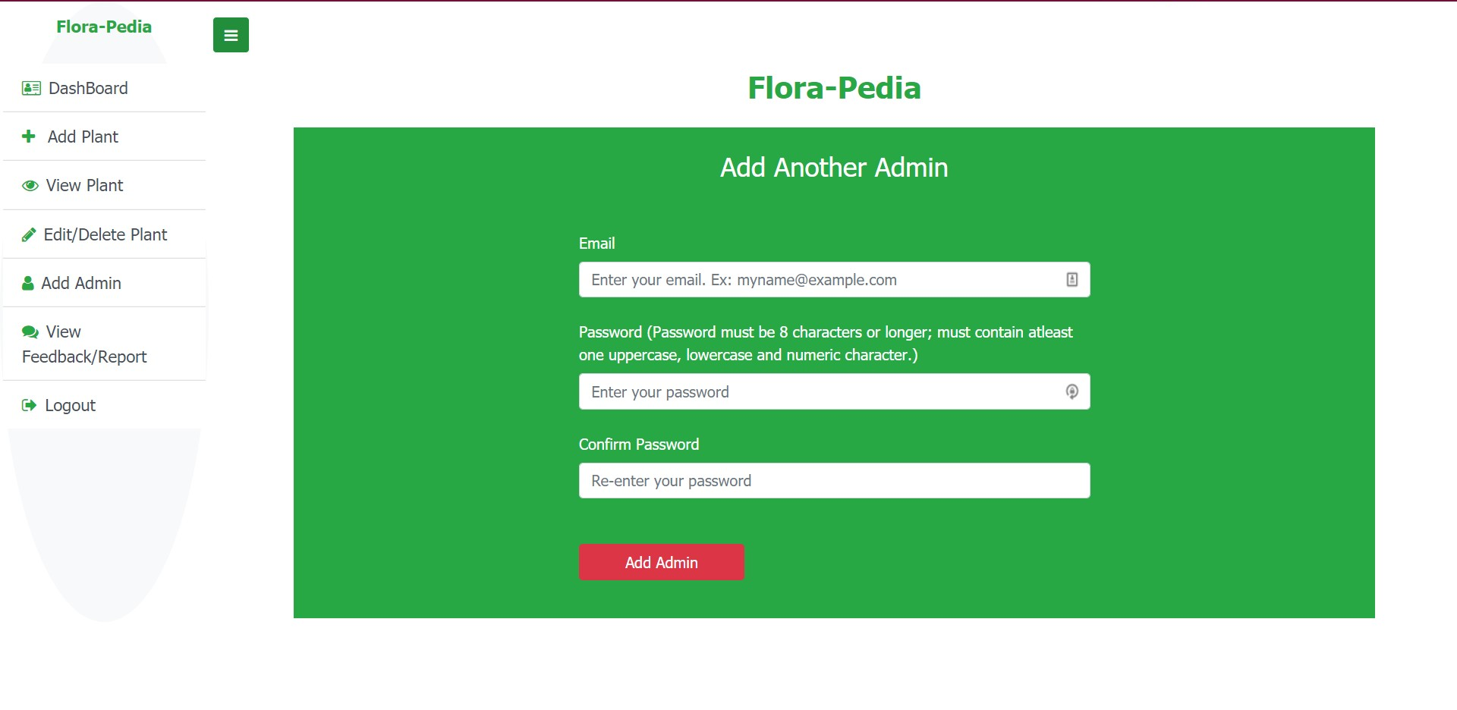

|  |  |
| --- | --- |
| **Files (User-end)** | **Description** |
| index.php | Homepage |
| style.css | CSS styling for User-end files |
| loginAsAdmin.php | Login as admin panel |
| loginValidation.php | Javascript form validation for  *loginAsAdmin.php* |
| browseAndDiscover.php | Displays all the plants in our database |
| displayDescriptionUserEnd.php | Displays the description and other info  of plants (User-end) |
| viewGallery.html | Displays the featured plants |
| about.html | Displays info about the site |
| aboutTheDev.html | Displays info about the developers |
| addFeedbackAndReport.php | For submitting a feedback or reporting  a problem |
| search.php | Searching plants |
| styleForSearch.css | CSS styling for *search.css* |

Files Structure and their Description (User-End):

Files Structure and Description (Admin-End):

|  |  |
| --- | --- |
| **Files(Admin-end)** | **Description** |
| main.php | Dashboard of Admin-end |
| styleForMain.css | CSS styling for Admin-end files |
| addAdmin.php | For adding administrators |
| addAdminValidation.js | Javascript form validation for *addAdmin.php* |
| addPlant.php | Adding plants |
| viewPlant.php | Displaying plants in tabular form |
| editPlant.php | Editing plants– Gives options to either edit plants or delete plants |
| edit_plant_detail.php | Contains backend code for editing a plant |
| delete_plant_detail.php | Contains backend code for deleting a plant |
| displayDescription.php | Displays description of plants(Admin-end) |
| viewFeedbackAndReport.php | Displays feedbacks and reports |
| delete_feedback_report.php | Contains backend code for deleting feedbacks/reports |
| logout.php | Logging out |

Files Structure and Description (Common files):

|  |  |
| --- | --- |
| **Common Files** | **Description** |
| dbConnect.php | Contains code for linking MySql database with PHP |
| plantService.php | For fetching the data from **plant_detail** table. |

Folders:

|  |  |
| --- | --- |
| **Folder Name** | **Description** |
| **images** | Stores the interface and gallery images of the website |
| **uploadedImages** | Stores all the plant images uploaded by the administrator |
| **database** | Contains the database file |
| **tinymce_editor** | Contains a plugin which provides rich text editing functionalities for HTML input elements |

**BIBLIOGRAPHY:**

1. **The Joy Of PHP Programming: A Beginner’s Guide to Programming Interactive Web Applications with PHP and MySql** by *Alan Forbes.*
2. **Head First PHP and MySql** by *Lynn Beighley and Michael Morrison*.
3. **Eloquent Javascript** by *Marjin Haverbeke*.
4. **HTML and CSS- The Complete Reference** by *Thomas Powell*.
5. **W3schools.com**
6. **Developer.mozilla.org** – *Mozilla Developer Network*.
7. **Stackoverflow.com** and other online forums.

-------------------------**END-**-------------------------